

**Technical Whitepaper**

**An Introduction to Neural Networks with kdb+**

**Author:**

James Neill works as a kdb+ consultant for one of the world's largest investment banks developing a range of applications. James has also been involved in the design of training courses in data science and machine learning as part of the First Derivatives training programme.

## TABLE OF CONTENTS

1. Introduction 3
2. Feedforward Networks 4
   1. The Perceptron 4
   2. Threshold Function 4
   3. Perceptrons as Linear Predictors 5
   4. A Neural Network 6
   5. Bias Neurons 7
   6. Weight Initialisation 7
   7. The Feedforward Network in kdb+ 8
3. Training the Network 9
   1. Back-propagation 9
4. Output Functions for Regression and Multi-class Classification 12
   1. Multiclass Outputs 12
   2. Nonlinear Regression Outputs 13
5. Classification for 3+ classes 15
6. Stochastic Gradient Descent 17
   1. Classification for 3+ classes using stochastic batch training 17
7. Conclusion 19

## INTRODUCTION

Due to the desire to understand the brain and mimic the way it works by creating machines that learn, neural networks have been studied with great interest for many decades. A simple mathematical model for the neuron was first presented to the world by Warren McCulloch and Walter Pitts in 1943.

With modern advances in technology and the computational power available, this field of research has had massive implications on how computers can be used to ‘think’ and learn to solve problems given an appropriate algorithm. A few interesting examples of this research in action include:

* Aiding in medical diagnostics<http://www.ijesit.com/Volume%202/Issue%202/IJESIT201302_33.pdf>
* Interpreting art and painting images<http://googleresearch.blogspot.ca/2015/06/inceptionism-going-deeper-into-neural.html><http://arxiv.org/pdf/1508.06576v1.pdf>
* Performing stock market predictions<http://reference.wolfram.com/applications/neuralnetworks/ApplicationExamples/12.2.0.html>

A number of different algorithms have been developed around this field of research, and this paper is going to focus on the implementation of a feedforward neural network in kdb+. A feedforward network (also known as a multi-layer perceptron) is a type of supervised machine learning algorithm which uses a series of nonlinear functions layered together with an output. It can be used for classification or regression purposes and has been shown to be a universal approximator – an algorithm that can model any smooth function given enough hidden units1.

This design of feedforward networks can be represented through operations on matrices and vectors. Array programming languages such as q/kdb+ are well suited for computational implementations in this format due to the vectorised operations on lists.

All tests were run using kdb+ version 3.2 (2015.05.07)

1 Kurt Hornik, “Approximation Capabilities of Multilayer Feedforward Networks”, *Neural Networks*, Vol. 4, pp. 251-257, 1991

## FEEDFORWARD NETWORKS

As mentioned in the introduction, a feedforward neural network is a type of supervised machine learning algorithm. This means that it is trained on datasets for which the output for given inputs is already known.

A neural network consists of a set of neurons connected together in some order. Each neuron receives inputs from other neurons, performs some action on these inputs and outputs a signal that becomes input for another connected neuron.

## The Perceptron

A single neuron by itself is often referred to as a perceptron (Figure 1). The idea is to construct a predictor based on a linear combination of the inputs and a set of weights which control the impact an input has on the system. This linear combination (the dot product of the inputs and the weights) is then used as the input to a chosen threshold function which produces the desired output.

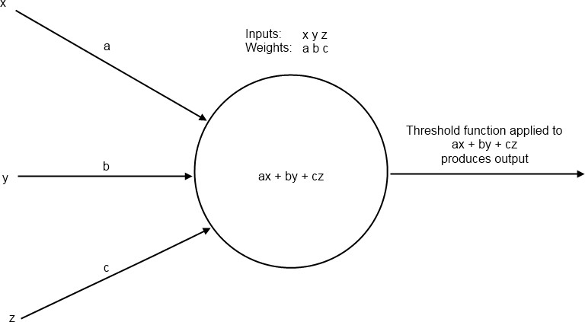

*Figure 1: A Perceptron*

## Threshold Function

A threshold function represents the activation of the perceptron based on its inputs. A common choice for this function is the sigmoid function. This function provides a smooth curve bounded asymptotically by 0 and 1 on the vertical axis (Figure 2).

1

𝜎(𝑥) = 1 + 𝑒−𝑥

q)sigmoid:{1%1+exp neg x} q)output:sigmoid[inputs mmu weights]

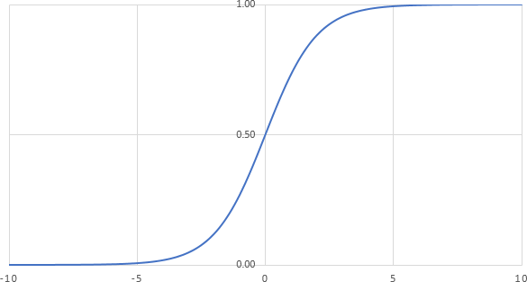

*Figure 2: A plot of the sigmoid function*

## Perceptrons as Linear Predictors

Perceptrons can only solve linearly separable problems. A linearly separable problem is one where two sets in a plane can be cleanly divided by a straight line. We can demonstrate this by looking at plots of truth table outputs.

Let us say that a red dot represents true and a blue dot represents false. If we take the standard truth table inputs of 1 or 0 and add some random noise to them so that they are either slightly smaller than 1 or slightly larger than 0, then we get the plots shown in Figure 3.

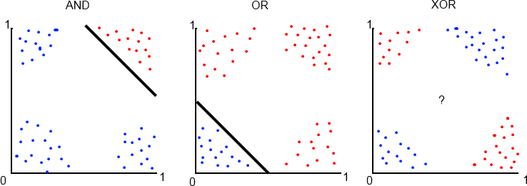

*Figure 3: Truth Table Plots*

Notice how we can easily separate the true results from false in the AND and OR truth tables with a straight line. Perceptrons are good predictors for these problems. However, if the data is not so easily separable, as with the XOR plot, we need a way to be able to make nonlinear predictions. Solving the XOR problem will form our motivation for connecting many perceptrons into a network.

## A Neural Network

A network consists of neurons connected together in layers as shown in Figure 4. Each neuron in one layer is connected to each neuron in the next layer and each connection has an associated weight. The first layer of neurons is the input layer. The neurons in this layer represent input values from a data sample.

Following the input layer are the hidden layers. The number of neurons in a hidden layer is determined through a combination of background understanding of the problem and trial and error.

Finally there is the output layer. The number of neurons in this layer is determined by the type of problem to be solved. For example one might wish to classify an input data sample into one of two categories (e.g. true or false as in the XOR problem). This type of problem is referred to as a *binary classification* problem. For this type of problem we only need one output neuron because the sigmoid function will return values close to 1 or 0 after the network is trained.

However, the function which acts on the linear combination of inputs and weights at the output layer is not always the same as the threshold function used throughout the rest of the network. This is because we do not always desire a value between 0 and 1. Output functions for addressing different types of problems will be discussed in detail in Section 4.

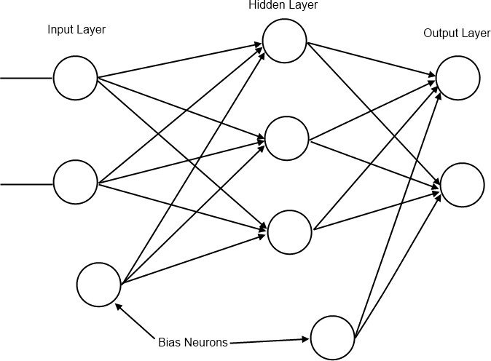

*Figure 4: A feedforward network*

## Bias Neurons

A bias neuron is a neuron external to the main network. One is added to the input layer and one to each of the hidden layers. The value it passes to neurons in the next layer is always 1 and it receives no inputs from previous layers (see Figure 4). The purpose of bias neurons is analogous to the intercept parameter of a simple linear model – commonly written as 𝑦 = 𝑚𝑥 + 𝑐 = 𝛽1𝑥1 + 𝛽0𝑥0.

The absence of 𝛽0𝑥0 in the simple linear model results in the predicted line always passing through (0, 0) and the model will perform poorly when attempting to predict unknown values. Hence we always set 𝑥0 to 1 and alter 𝛽0 as we find the line of best fit. In the neural network we represent the network’s version of the 𝛽0𝑥0 term as a bias neuron and associated weights. For more information on bias terms in statistical modelling see Chapter 3 in [2] and Chapter 7 in [1].

Bias neurons are added to the input layer by adding a 1 to each of the input samples in the data set used to train the network.

// Inputs and expected target values for XOR problem q)input:((0 0f);(0 1f);(1 0f);(1 1f))

// Add a bias neuron to each input

q)input:input,’1.0

q)target:0 1 1 0f

## Weight Initialisation

The initialization process begins by assigning values to the weights present in the network. The weights are randomly assigned such that the values of the weights between the input nodes and a receiving node on the next layer are in the range (-1, 1) with mean 0.

Since there will be multiple neurons in the next layer we can represent all the weights between two layers as a matrix, where the number of rows represents the number of inputs and the number of columns represents the number of neurons in the next layer. An example of how this weight matrix and the input matrix interact is shown in Figure 5.

wInit:{

// If only one input neuron is detected exit

// This is most likely due to a missing bias neuron if[1=x;:"Number of input neurons must be greater than 1."]; flip flip[r]-avg r:{[x;y]x?1.0}[y]each til x

}

// Init weights between 3 inputs and 4 outputs

// The first column represents the weights (connections) between the 3 inputs and the first neuron in the next layer.

// The second column is the weights leading to the second neuron in the next layer and so on.

q)wInit[3;4]

-0.3586151 0.09051553 -0.2815408 -0.05282783

0.02154042 0.4219367 0.2320934 -0.05853578

0.3370747 -0.5124522 0.04944742 0.1113636

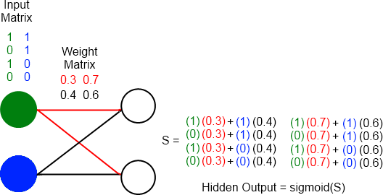

*Figure 5: Diagram showing 2 input neurons (green and blue neurons) connecting to 2 hidden neurons. The colours in the matrices correspond with the area of the network those values are found during execution of a forward pass.*

## The Feedforward Network in kdb+

Once we have prepared the input data and the weights they can be applied to the network to provide output. We will use the network to predict the outputs of the XOR function.

// weights between input layer and hidden layer (2 inputs + 1 bias neuron)

q)w:wInit[3;4]

// weights between hidden layer and output layer (4 hidden neurons + 1 bias neuron)

q)v:wInit[5;1]

q)ffn:{[input;w;v]

// Apply inputs and their weights to the hidden layer z:sigmoid[input mmu w];

// Use output from hidden layer to generate an output sigmoid[z mmu v]

}

q)ffn[input;w;v] 0.5028818

0.5136649

0.4891303

0.5

The network has produced an output, but these values are not close to the target values. This is understandable as the weights have been randomly initialized. In order to produce the desired output the network must learn a more appropriate set of weights.

## TRAINING THE NETWORK

Training a network to produce accurate results involves determining the weights which minimise the errors of the output nodes. The problem of minimising the error by adjusting the weights is solved by a technique called back-propagation - a form of gradient descent.

Gradient descent begins by calculating the derivative of the error function with respect to the weights. This derivative gives information about the direction needed to move along the surface described by the error function in order to arrive at a minimum. The weights are gradually adjusted using this information until an acceptable minimum in error has been reached.

## Back-propagation

Back-propagation trains the network by propagating information about the error at the output back through the network and adjusting all the weights of the connecting neurons. For an output node that applies the sigmoid function the error function is the cross-entropy error function defined as:

− ∑ 𝑦𝑡 log 𝑦̂𝑡 + (1 − 𝑦𝑡) log(1 − 𝑦̂𝑡)

𝑡

This gives us the following update rule for adjusting the weights between the output node and the hidden layer2:

∆𝑣ℎ = ∑ 𝑧𝑡 (𝑦𝐭 − 𝑦̂𝑡)

ℎ

𝑡

𝑣ℎ ← 𝑣ℎ + 𝛼∆𝑣ℎ

Where 𝑧𝑡 is the output after evaluating the hidden neuron *h* for input sample *t*, 𝑣ℎ is the weight between the output neuron and hidden neuron *h*, 𝑦𝐭 is the of target for sample *t*, 𝑦̂𝑡 is the calculated output for sample *t* and 𝛼 is the rate at which we adjust the weights (usually < 0.1).

ℎ

Once the change in the above weights has been calculated we propagate the error to the hidden layer and generate the update rule for the weights between the input layer and the hidden layer:

∆𝑤ℎ𝑗 = ∑(𝑦𝑡 − 𝑦̂𝑡) 𝑣ℎ𝑧𝑡(1 − 𝑧𝑡 )𝑥𝑡

ℎ ℎ 𝑗

𝑡

𝑤ℎ𝑗 ← 𝑤ℎ𝑗 + 𝛼∆𝑤ℎ𝑗

Where 𝑤ℎ𝑗 is the weight between hidden neuron *h* and input neuron *j* and 𝑥𝑡 is the input from neuron

𝑗

*j* for some sample *t*.

Using these formulas we can update our feed forward network function to implement back- propagation and allow training:

2 The derivation of the update rules for back-propagation is beyond the scope of this paper. See Chapter 11 in [3] and Chapter 11 in [2]*.*

// inputs - the input data set with bias node

// targets – known outputs corresponding to inputs

// lr – learning rate ‘alpha’

// d – dictionary with 3 items: output

// weights between input and hidden layers

// weights between hidden and output layers q)ffn:{[inputs;targets;lr;d]

z:1.0,/:sigmoid[inputs mmu d`w]; o:sigmoid[z mmu d`v];

// Error of output neurons deltaO:(targets-o);

// Error of hidden neurons deltaZ:1_/:$[deltaO;flip d`v]*z*1-z;

`o`v`w!(o;d[`v]+lr*flip[z] mmu deltaO; d[`w]+lr*flip[inputs] mmu deltaZ)

}

// Example – the XOR problem q)inputs

0 0 1

0 1 1

1 0 1

1 1 1

q)targets 0 1 1 0f

q)w

0.3257579 0.348099 -0.4320058 0.3356597

-0.07237444 -0.3028193 0.3088185 -0.3069554

-0.2533834 -0.04527963 0.1231874 -0.02870423

q)v

-0.0133154

0.04739764

0.2894549

-0.3235371

// Two training passes shows little change q)finalResult:(ffn[inputs;targets;0.1]/)[2;`o`w`v!(0,();w;v)] q)finalResult`o

0.5025557

0.5133001

0.4888265

0.4996545

// 10000 training passes shows significant improvement q)finalResult:(ffn[inputs;targets;0.1]/)[10000;`o`w`v!(0,();w;v)] q)finalResult`o

0.009305227

0.9890354

0.9890087

0.01142469

q)\ts finalResult:(ffn[inputs;targets;0.1]/)[10000;`o`w`v!(0,();w;v)] 164 2992

Now that the network has been trained it can be applied to a random permutation of XOR inputs to see how it performs on a single pass.

// generate a random permutation of list 0 to 99 q)rp:-100?til 100

// use rp to shuffle inputs and targets

// we generate rp first so that the shuffled indices of

// the inputs and targets match up q)inputs:(100#inputs)rp q)targets:(100#targets)rp

// using weights of trained network solve test inputs q)rw:finalResult`w; rv:finalResult`v

q)res: (ffn[inputs;targets;0.1]/)[1;`o`w`v!(0;rw;rv)]

// Are all the predictions correct?

q) all raze[`int$res`o]=targets 1b

## OUTPUT FUNCTIONS FOR REGRESSION AND MULTI-CLASS CLASSIFICATION

There are three types of output we are looking for when using a network of this type. The first we have already discussed in Section 2.4 – binary classification. We have also worked through an example of this problem when applying the network to predict XOR outputs. The other two problems we will discuss are multiclass outputs and nonlinear regression outputs.

## Multiclass Outputs

For multiclass outputs the goal is to determine the correct classification of an input into three or more possible classifications. Unlike the binary classification situation, in the output layer there will be one neuron for each possible classification. The target values are transformed using one-hot encoding. This gives us a unique list of 0s and 1s for each possible classification that is the same length as the number of possible classifications. For example, if there are classifications A, B and C the transformations are 0 0 1, 0 1 0 and 1 0 0 – giving the output layer target patterns to match for training and testing. The output function used is the softmax function:

exp 𝑆𝑡

𝑡 𝑖

# 𝑦̂ =

𝑖 ∑𝑘 𝑒𝑥𝑝 𝑆𝑡

𝑘

Where 𝑦̂𝑡 is the output from neuron *i* for sample *t*, 𝑆𝑡 is the linear combination of outputs from the

𝑖 𝑖

hidden layer and the weights connecting the hidden layer to output neuron *i* for sample *t* and 𝑆𝑡 is the linear combination of outputs from the hidden layer and the weights connecting the hidden layer to output neuron *k* for sample *t*.

𝑘

By using the softmax function we ensure that the sum of the outputs from each of the neurons in the output layer is 1. That allows us to pick the neuron with the highest output value as the most likely to be the classification we expect for the given input; the ‘winning’ neuron will be assigned a value of 1 and the other neurons a value of 0 resulting in a match to one of the one-hot encoded classifications. The cross-entropy error function in this case is:

− ∑ ∑ 𝑦𝑡 log 𝑦̂𝑡

𝑖 𝑖

𝑡 𝑖

Where 𝑦𝑡 is the target value for output neuron *i* with sample *t*.

𝑖

The update rules are:

∆𝑣𝑖ℎ = ∑(𝑦𝑡 − 𝑦̂𝑡)𝑧𝑡

𝑖 𝑖 ℎ

𝑡

∆𝑤ℎ𝑗 = ∑ [∑(𝑦𝑡 − 𝑦̂𝑡)𝑣𝑖ℎ] 𝑧𝑡 (1 − 𝑧𝑡 )𝑥𝑡

𝑖 𝑖

𝑡 𝑖

ℎ ℎ 𝑗

Where 𝑣𝑖ℎ is the weight between output neuron *i* and hidden neuron *h*.

An example implementation of the softmax output will be shown in Section 5.

// one-hot encoding function q)oneHot:{x!`float$x=/:x} q)oneHot `A`B`C

A| 1 0 0

B| 0 1 0

C| 0 0 1

q)smax:{exp[x]%sum flip exp x} q)smaxErr:{neg sum sum flip x*log y}

## Nonlinear Regression Outputs

If the goal is to predict a real value, not necessarily constrained within the boundaries imposed by a threshold function, the output function is just the linear combination of the outputs from the hidden layer.

𝑦̂𝑡 = 𝐯 ∙ 𝐳𝑡

Where **v** is the vector of weights between the hidden layer and the output layer and 𝐳𝑡 is the vector of outputs from the hidden layer.

In this case we change the error function from cross-entropy to the sum-of-squared errors:

1 ∑(𝑦𝑡 − 𝑦̂𝑡)2

2

𝑡

The update rules for a regression output are:

∆𝑣ℎ = ∑(𝑦𝑡 − 𝑦̂𝑡)𝑧𝑡

ℎ

𝑡

∆𝑤ℎ𝑗 = ∑(𝑦𝑡 − 𝑦̂𝑡)𝑣ℎ𝑧𝑡(1 − 𝑧𝑡 )𝑥𝑡

ℎ ℎ 𝑗

𝑡

q)lin:{x}

q)linErr:{0.5*sum sum a*a:x-y}

It’s useful now to put the different functions for error and output in dictionary format as this will allow us to use the same ffn function for all 3 types of classification:

// x is linear combination of hidden outputs and weights q)outputFuncs:`sig`smax`lin!

({1%1+exp neg x};{exp[x]%sum flip exp x};{x})

// x is target value, y is calculated

q) errFuncs:`sig`smax`lin!

({neg sum sum flip(x*log y)+(1-x)*log 1-y};

{neg sum sum flip x*log y};{sum sum a*a:x-y})

q)ffn:{[inputs;targets;lr;of;d]

// Calculate the outputs of the hidden layer

// and add bias node z:1.0,/:sigmoid[inputs mmu d`w]; o:outputFuncs[of][z mmu d`v];

// Error of output neurons deltaO:(targets-o);

// Error of hidden neurons

// Hidden bias node is not connected to any

// input layer nodes so we drop it deltaZ:1_/:$[deltaO;flip d`v]*z*1-z;

`o`v`w`err!(o; d[`v]+lr*flip[z] mmu deltaO; d[`w]+lr*flip[inputs] mmu deltaZ; errFuncs[of][targets;o])

}

## CLASSIFICATION FOR 3+ CLASSES

As an example, we will study a set of Iris flower data which was originally introduced into research by Ronald Fisher in 1936. It contains samples from three different species of the Iris flower and has become a standard test case for many classification techniques within machine learning. By taking measurements of certain metrics (eg. length and width of sepals) the plants can be classified and computationally distinguished from each other. The data and a description of the data can be found in the links at [http://archive.ics.uci.edu/ml/machine-learning-databases/iris.](http://archive.ics.uci.edu/ml/machine-learning-databases/iris)

We one-hot encode the different possible species of Iris, resulting in a neural network with 5 inputs (including the bias neuron), 7 hidden neurons (including the bias neuron) and 3 outputs. The data set is randomly shuffled to reduce the likelihood of a biased output. From this randomised selection of the data a random selection of 20 samples is taken as the test set and the other 130 samples are used in training.

// one-hot encoding of classes q)IrisOneH:oneHot[distinct Iris.species] q)IrisOneH

Iris-setosa | 1 0 0

Iris-versicolor| 0 1 0

Iris-virginica | 0 0 1 q)Iris1h

slength swidth plength pwidth species onehot

------------------------------------------------

|  |  |  |  |  |
| --- | --- | --- | --- | --- |
| 5.1 | 3.5 | 1.4 | 0.2 | Iris-setosa 1 0 0 |
| 4.9 | 3 | 1.4 | 0.2 | Iris-setosa 1 0 0 |
| 4.7 | 3.2 | 1.3 | 0.2 | Iris-setosa 1 0 0 |
| .. |  |  |  |  |

// Random permutation of the dataset q)IrisRP:Iris1h{neg[x]?til x}count Iris1h

// Pick a test set – samples from data not used in training q)IrisTest:IrisRP[-20?count IrisRP]

q)IrisTrain:IrisRP except IrisTest

// Init weights, input and output variables q)w:wInit[5;6]

q)v:wInit[7;3]

q)input:1.0,'flip flip[IrisTrain]`slength`swidth`plength`pwidth q)output:IrisTrain.onehot

// Train network q)resIris:(ffn[input;output;0.01;`smax]/)[800;`o`w`v`err!(0;w;v;1f)]

// After 800 iterations (or epochs) how well does it perform? q)all(IrisOneH?"f"$"j"$resIris`o)=IrisOneH?output

0b

q)100*sum[(IrisOneH?"f"$"j"$resIris`o)=IrisOneH?output]%count output 96.89922

// Init variables for test data

q)tinput:1.0,'flip flip[IrisTest]`slength`swidth`plength`pwidth q)toutput:IrisTest.onehot

// Run test data through network without training q)resIrisT:(ffn[tinput;toutput;0.01;`smax]/)[1;

`o`w`v`err!(0;resIris`w;resIris`v;1f)]

q)all (IrisOneH?"f"$"j"$resIrisT`o)=IrisOneH?toutput 1b

Plot of error vs training epoch is given in Figure 6. We see that the error settles into an oscillation pattern around training epoch 700. While these oscillations are slowly converging it is likely that overfitting begins to take place shortly after the 700th iteration of training.

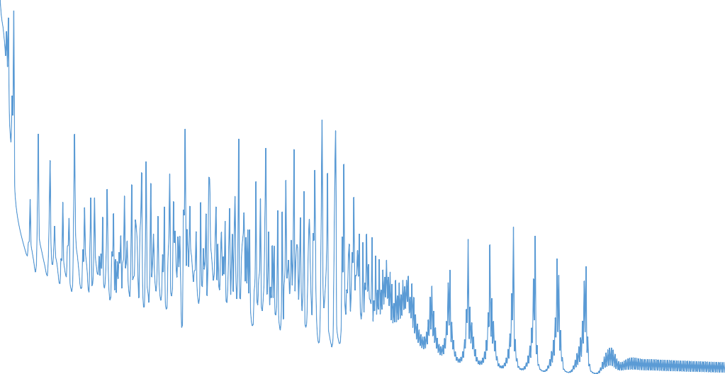

Training Feedforward Network for Iris Dataset

160

140

120

100

80

60

40

20

0

0

100

200

300

400

Training Epoch

500

600

700

800

Error

|  |  |  |  |  |  |  |  |
| --- | --- | --- | --- | --- | --- | --- | --- |
|  |  |  |  |  |  |  |  |
|  |  |  |  |  |  |  |  |
|  |  |  |  |  |  |  |  |
|  |  |  |  |  |  |  |  |
|  |  |  |  |  |  |  |  |
|  |  |  |  |  |  |  |  |
|  |  |  |  |  |  |  |  |
|  |  |  |  |  |  |  |  |

*Figure 6: Error while training network on Iris dataset*

## STOCHASTIC GRADIENT DESCENT

Often, in practice, computing the error and gradient for the entire training set can be very slow and in some cases not possible if the data will not fit entirely in memory. Stochastic gradient descent solves this problem by performing the back-propagation training on small batches of the training set chosen at random.

Randomly chosen batches simulate real-time streaming of data and help to reduce bias in the final trained network (see chapter 7 in [2] for more details on bias and variance in machine learning).

sffn:{[inputs;targets;lr;of;bsize;d]

// random permutation for selection from inputs of size bsize rp:bsize?til count inputs; ffn[inputs[rp];targets[rp];lr;of;d]

}

// inputs[rp] and targets[rp] assume the input and targets

// are all contained in memory. If taking the data from

// disk a different query would be required to get the random

// selection of data.

// The important thing is that the input-target pairs in a

// batch are selected randomly with replacement (i.e. the

// same input-target pair can appear more than once in a

// batch)

## Classification for 3+ classes using stochastic batch training

This time we will again use Fisher’s Iris dataset, but the network will be trained using randomly selected small batches from the training data.

q)IrisTest:Iris1h[-20?count Iris1h] q)IrisTrain:Iris1h except IrisTest

q)input:1.0,'flip flip[IrisTrain]`slength`swidth`plength`pwidth q)target:IrisTrain`onehot

// choose a batch size of 12 q)resIris:(sffn[input;target;0.01;`smax;12]/)[800;

`o`w`v`err!(0;w;v;1f)]

q)tinput:1.0,'flip flip[IrisTest]`slength`swidth`plength`pwidth q)toutput:IrisTest.onehot

q) resIrisT:(ffn[tinput;toutput;0.01;`smax]/)[1;

`o`w`v`err!(0;resIris`w;resIris`v;1f)]

q)all (IrisOneH?"f"$"j"$resIrisT`o)=IrisOneH?toutput 1b

800

700

600

500

400

Training Epoch

300

200

100

0

0

2

4

6

8

10

12

14

16

Stochastic Training Error for Batch Size 12

800

700

600

500

400

Training Epoch

300

200

100

0

0

5

10

15

20

25

30

Stochastic Training Error for Batch Size 25

Error

Error

## CONCLUSION

In this whitepaper we have explored a proof-of-concept implementation of a feedforward network in kdb+. By constructing the model for the network using linear algebra (inputs, outputs and weights represented by matrices) we have shown that an array processing language is well suited to developing a complex system.

We have shown that multiple types of output functions can be easily applied to the network depending on the desired result. This generalisation demonstrates the flexibility of kdb+ to many problems where numerical data can be arranged into lists, arrays or tables.

In the event that there is not enough main memory to carry out the calculations on all the training data in one pass we presented an alternative approach, stochastic gradient descent, which allows the network to be trained on small batches of the data.

The network exhibited in this paper forms the groundwork for more complicated networks. Adding additional hidden layers and different options for threshold function will allow more complex convolutional and deep networks to be developed.

All tests were run using kdb+ version 3.2 (2015.05.07) References:

1. Murphy, K. P. (2012). *Machine Learning A Probabilistic Perspective.* MIT Press.
2. Hastie, T., Tibshirani, R. and Friedman, J. *The Elements of Statistical Learning.* Springer, New York. (link to online version: [http://statweb.stanford.edu/~tibs/ElemStatLearn/)](http://statweb.stanford.edu/%7Etibs/ElemStatLearn/))
3. Alpaydin, E. *Introduction to Machine Learning, Second Edition.* MIT Press.